AI-POWERED JOB RECRUITMENT & CANDIDATE MANAGEMENT SYSTEM
User Story:
As a recruiter in an organization, I want to efficiently manage candidate information and streamline the entire recruitment process using our AI-Powered Job Recruitment & Candidate Management System.
I want to easily create, access, and update candidate profiles, job openings, and application records while tracking each candidate through different stages of the hiring process, enabling a transparent and organized recruitment workflow.
Additionally, I need the application to automate candidate screening, approval workflows, interview scheduling, and email notifications to reduce manual effort, improve hiring accuracy, and speed up the recruitment process.
Moreover, I require the ability to generate comprehensive reports and interactive dashboards to monitor recruitment metrics such as candidate applications, interview status, hiring progress, recruiter performance, and job vacancy trends, enabling data-driven decision-making.
Lastly, I would like the application to automatically send email notifications to candidates regarding application submission, interview schedules, approval status, offer letters, and final hiring decisions, thereby enhancing communication, improving the candidate experience, and increasing overall recruitment efficiency.

1. INTRODUCTION
1.1 Project Overview
The project “AI-Powered Job Recruitment & Candidate Management System” focuses on developing a Salesforce-based recruitment management application that uses automation and artificial intelligence to streamline the hiring process. The system is designed to efficiently manage candidates, recruiters, hiring managers, job applications, and recruitment activities through a centralized platform.
The application enables organizations to maintain candidate profiles, manage job postings, track application progress, and automate recruitment workflows. Salesforce features such as custom objects, record-triggered flows, email alerts, validation rules, reports, and dashboards are used to improve recruitment efficiency and reduce manual effort.
The integration of AI capabilities helps in enhancing candidate evaluation, improving decision-making, and providing better recruitment insights. The system ensures faster communication between candidates and recruiters through automated notifications and provides a structured approach for managing the complete hiring lifecycle.
The project user story, requirements, and objectives are defined in the initial section of the document.

1.2 Purpose
The purpose of this project is to develop an intelligent recruitment management system that simplifies and automates the hiring process. The main objectives are:
- To streamline the recruitment process by managing candidates, recruiters, and job applications efficiently.
- To automate repetitive recruitment tasks using Salesforce automation tools and AI capabilities.
- To maintain accurate and centralized candidate and job-related information.
- To reduce manual errors and improve data consistency through validation and workflow automation.
- To enhance candidate evaluation and support better hiring decisions using AI-powered insights.
- To provide automated email notifications for application updates, approvals, interviews, and recruitment activities.
- To generate reports and dashboards for analyzing recruitment performance and improving decision-making.

2. IDEATION PHASE
2.1 Problem Statement

PS | I am (Customer) | I’m trying to | But | Because | Which makes me feel
PS-1 | Recruiter | Find suitable candidates and manage the recruitment process efficiently | Candidate screening and tracking are time-consuming | Applications are managed manually and there is no intelligent automation for filtering candidates | Overwhelmed and inefficient
PS-2 | Hiring Manager | Review candidate profiles and select the best candidates | It is difficult to compare and evaluate candidates quickly | Candidate information is scattered and there are limited insights for decision-making | Confused and delayed in hiring decisions
PS-3 | Job Applicant/Candidate | Apply for jobs and receive updates about my application status | I do not receive timely notifications about my application progress | There is no automated communication system for recruitment updates | Uncertain and disconnected
PS-4 | HR Administrator | Maintain recruitment records and monitor hiring activities | Managing large amounts of candidate and job data is difficult | Data is stored manually without centralized management and automation | Stressed and inefficient

2.2 Empathy Map Canvas
Target Users
- Recruiters
- Hiring Managers
- Job Applicants/Candidates
- HR Administrators
Empathy Analysis

Aspect | Description
Think & Feel | Need an efficient recruitment process, accurate candidate information, faster candidate evaluation, and better hiring decisions.
Hear | Feedback from hiring teams, candidates, and management regarding recruitment delays and communication issues.
See | Large numbers of applications, resumes, spreadsheets, and manual recruitment records that are difficult to manage.
Say & Do | Review candidate profiles, track applications, update recruitment status, and perform hiring activities manually.
Pain | Time-consuming candidate screening, delayed communication, inaccurate data, manual errors, and difficulty managing multiple applications.
Gain | AI-powered candidate management, automated workflows, faster screening, real-time updates, accurate reports, and improved recruitment efficiency.

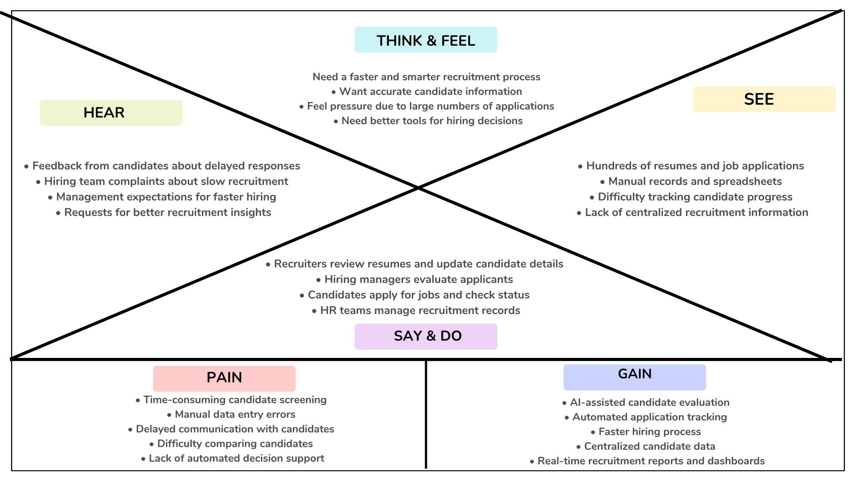
2.3 Brainstorming
Brainstormed Ideas
- Manual recruitment management system
- Excel-based candidate tracking system
- Web-based recruitment portal
- Salesforce-based recruitment management system
- AI-powered candidate screening system
- Automated email notification system
- Recruitment analytics and reporting dashboard
Selected Idea:
AI-Powered Job Recruitment & Candidate Management System using Salesforce
The selected idea focuses on developing a Salesforce-based recruitment application integrated with AI capabilities to automate hiring processes, manage candidate information, streamline application tracking, and improve decision-making through intelligent insights and automation.

3. REQUIREMENT ANALYSIS PHASE
3.1 Customer Journey Map
Journey Stages:
Stage | Description
Login | Users securely log in to the Salesforce application using their credentials.
Access Recruitment Application | Recruiters, hiring managers, and administrators access the recruitment system based on their roles and permissions.
Enter Candidate Data | Recruiters add and update candidate profiles, resumes, skills, and application details.
Post & Manage Job Applications | Recruiters create job openings and track candidate applications through different hiring stages.
Candidate Evaluation | Hiring managers review candidate profiles and evaluate applicants using available insights.
View Reports & Dashboards | Users analyze recruitment data, application status, and hiring performance through reports and dashboards.
Decision Making | Hiring managers make informed recruitment decisions using accurate candidate information and AI-powered insights.

3.2 Solution Requirements
Functional Requirements
FR No | Requirement
FR-1 | User Login and Role-Based Access
FR-2 | Candidate, Recruiter, and Job Object Creation
FR-3 | Candidate Data Entry and Profile Management
FR-4 | Job Application Tracking Automation
FR-5 | Report and Dashboard Generation
FR-6 | Automated Email Notifications
FR-7 | AI-Based Candidate Evaluation and Recruitment Assistance
FR-8 | Workflow and Record-Triggered Automation

Non-Functional Requirements
NFR-1: Usability
The system should provide an easy-to-use interface for recruiters, hiring managers, candidates, and administrators without requiring advanced technical knowledge.
Requirements:
- Simple and intuitive user interface
- Easy navigation between recruitment modules
- User-friendly candidate and job forms
- Clear dashboards and reports
Example:
A recruiter should be able to log in, add candidate details, update application status, and send notifications within a few minutes.
Salesforce Lightning UI provides drag-and-drop components and simplified navigation.

NFR-2: Security
The system must protect candidate, recruiter, and company information from unauthorized access.
Requirements:
- Role-based access control
- Secure authentication
- Data privacy protection
- Permission-based access to records
Examples:
- Profiles and permission sets
- Object-level and field-level security
- Restricted access to candidate information
- Secure login policies
NFR-3: Reliability
The recruitment system should operate consistently and store candidate and job data accurately without data loss.
Requirements:
- Automatic data saving
- Error handling mechanisms
- Regular data backup
- Reliable cloud infrastructure
Example:
If a recruiter updates a candidate's application status and faces a network issue, the system should preserve the entered information.
Salesforce cloud infrastructure provides reliable data storage and backup.

NFR-4: Performance
The system should provide quick responses and efficiently handle large volumes of candidate and job data.
Requirements:
- Fast page loading
- Quick report generation
- Smooth dashboard performance
- Minimal processing delay
Example:
When an HR manager generates recruitment reports containing thousands of applications, the system should display results quickly.
Optimized Salesforce queries and automation improve system performance.

NFR-5: Availability
The system should be accessible whenever recruiters and hiring managers need it.
Requirements:
- 24/7 system availability
- Minimal downtime
- Cloud-based deployment
- Disaster recovery support
Example:
Recruiters should be able to access candidate information and update hiring progress during any stage of recruitment.
Salesforce provides high availability through its cloud platform.

NFR-6: Scalability
The system should support organizational growth and increasing recruitment data without affecting performance.
Requirements:
- Support multiple users
- Handle increasing candidate records
- Expand storage capacity
- Maintain system efficiency
Example:
If an organization receives thousands of job applications across multiple job openings, the system should continue to manage candidate data efficiently.
Salesforce infrastructure supports scalability as business requirements grow.
3.3 Data Flow Diagram
Data Flow:
User → Salesforce Lightning UI → Custom Objects → Validation Rules → Record-Triggered Flows → AI Processing → Reports → Dashboards
Description:
- Users interact with the Salesforce Lightning interface to perform recruitment activities.
- Candidate, recruiter, and job-related information is stored in custom objects.
- Validation rules ensure accurate and complete data entry.
- Record-triggered flows automate recruitment processes such as status updates and email notifications.
- AI capabilities assist in candidate evaluation and recruitment insights.
- Reports and dashboards provide analytics for better hiring decisions.

3.4 Technology Stack
Layer | Technology
Frontend | Salesforce Lightning Experience
Database | Salesforce Cloud Database
Automation | Salesforce Flows, Record-Triggered Flows
Backend | Salesforce Platform, Apex (if required)
AI Integration | Salesforce Agentforce / AI Capabilities
Analytics | Salesforce Reports & Dashboards
Security | Profiles, Permission Sets, Role-Based Access Control

4. PROJECT DESIGN PHASE
4.1 Problem–Solution Fit
The AI-Powered Job Recruitment & Candidate Management System replaces traditional manual recruitment processes with an automated and intelligent Salesforce-based solution. The system centralizes candidate, recruiter, and job information in Salesforce Cloud, reducing data duplication, manual errors, and delays in the hiring process.
Automation using Salesforce Flows improves recruitment efficiency by managing application updates, approvals, and notifications. AI-powered features assist recruiters in candidate evaluation and decision-making, while reports and dashboards provide real-time recruitment insights. This ensures faster, accurate, and efficient hiring management.

4.2 Proposed Solution
Functional Requirements
Parameter | Description
User Login & Authentication | Allows authorized recruiters, hiring managers, and administrators to securely log in to the recruitment system using valid credentials.
Candidate Record Management | Enables users to create, view, update, and manage candidate details such as name, contact information, skills, qualifications, resume details, and application status.
Recruiter & Hiring Manager Management | Allows management of recruiter and hiring manager information for efficient coordination of recruitment activities.
Job Management | Supports creation, updating, and tracking of job openings including job title, required skills, experience, and job descriptions.
Application Management | Enables tracking of candidate applications through different stages such as Applied, Screening, Interview, Selected, and Rejected.
AI-Based Candidate Evaluation | Uses AI capabilities to analyze candidate information and provide insights to support better hiring decisions.
Validation Rules | Ensures accurate data entry by validating fields such as email, phone number, required fields, and application details.
Record Types & Page Layouts | Provides customized views and layouts for different users such as recruiters, candidates, and hiring managers.
Global Picklists | Maintains standardized values for fields such as application status, job type, experience level, and candidate category.
Email Notification System | Sends automated emails to candidates and recruiters for application updates, interview schedules, approvals, and recruitment status changes.
Workflow & Flow Automation | Automates recruitment tasks such as updating application status, sending notifications, and triggering approval processes using Salesforce Flows.
Report Generation | Generates recruitment reports including candidate applications, hiring progress, job performance, and recruiter activities.
Dashboard Visualization | Displays real-time recruitment analytics using interactive dashboards, charts, and performance metrics.
Data Backup & Recovery | Ensures secure storage, backup, and recovery of candidate and recruitment data using Salesforce Cloud.
User Role Management | Controls system access using profiles, roles, and permission sets for recruiters, hiring managers, and administrators.

4.3 Solution Architecture
Architecture Layers
1. Presentation Layer – Salesforce Lightning UI
- Provides the user interface for recruiters, hiring managers, and administrators.
- Allows users to manage candidates, jobs, and applications.
2. Application Layer – Salesforce Flows & AI Logic
- Handles automation, business rules, approval processes, email alerts, and AI-powered recruitment assistance.
3. Data Layer – Custom Objects
- Stores candidate details, recruiter information, job postings, and application records securely in Salesforce Cloud.
4. Analytics Layer – Reports & Dashboards
- Provides recruitment insights through reports, charts, and dashboards for better decision-making.
This layered architecture ensures modularity, scalability, security, and maintainability of the AI-powered recruitment system.

5. PROJECT PLANNING & SCHEDULING
5.1 Project Planning
- The project followed an Agile-based development approach with planned sprints and milestones.
- A Salesforce Developer account was created to configure the development environment.
- Custom objects were designed to manage Candidate, Recruiter, Hiring Manager, Job, and Application data.
- Custom tabs and a Salesforce Lightning Application were created for easy navigation.
- Fields, relationships, and global picklists were configured to maintain data consistency.
- Page layouts and record types were created according to different user roles and recruitment processes.
- Validation rules were implemented to ensure accurate candidate and job information.
- Email templates and automated flows were developed for application updates and recruitment notifications.
- AI-powered features were integrated to assist candidate evaluation and improve recruitment decisions.
- Reports and dashboards were created to monitor recruitment performance and hiring analytics.
- Regular sprint reviews, testing, and debugging were conducted to track progress and resolve issues.
- The project was completed within the planned timeline through systematic scheduling and task management.

Product Backlog, Sprint Schedule, and Estimation
Sprint | Functional Requirement (Epic) | User Story Number | User Story / Task | Story Points | Priority | Team Members
Sprint-1 | Developer Setup | USN-1 | As an admin, I want to create a Salesforce Developer account so that I can configure and deploy the AI-powered recruitment application. | 1 | High | Member 1
Sprint-1 | Data Modeling | USN-2 | As an admin, I want to create Candidate, Recruiter, Hiring Manager, Job, and Application objects so that recruitment data can be stored systematically. | 5 | High | Member 2
Sprint-2 | Application Setup | USN-3 | As a user, I want separate tabs for recruitment objects so that I can easily navigate and manage records. | 3 | High | Member 3
Sprint-2 | Application Setup | USN-4 | As a manager, I want a dedicated Lightning App so that all recruitment operations are accessible from a single dashboard. | 3 | High | Member 4
Sprint-2 | Data Modeling | USN-5 | As an admin, I want to create candidate and job fields so that complete recruitment details can be captured accurately. | 5 | Medium | Member 1
Sprint-2 | Customization | USN-6 | As a user, I want customized page layouts for different records so that relevant information is displayed during data entry. | 5 | High | Member 2
Sprint-2 | Customization | USN-7 | As an admin, I want record types for different application categories so that recruitment processes can be managed efficiently. | 5 | Medium | Member 3
Sprint-3 | Automation | USN-8 | As a system, I want to validate candidate and job details so that incorrect data entries are prevented. | 3 | High | Member 4
Sprint-3 | Automation | USN-9 | As a system, I want automated flows to send email notifications so that candidates and recruiters receive timely updates. | 5 | High | Member 1
Sprint-4 | AI & Automation | USN-10 | As a system, I want AI-powered candidate evaluation support so that recruiters can make better hiring decisions. | 5 | High | Member 2
Sprint-5 | Reports | USN-11 | As a hiring manager, I want recruitment reports so that I can monitor applications and hiring performance. | 4 | High | Member 3
Sprint-6 | Dashboards | USN-12 | As a manager, I want visual dashboards so that I can analyze recruitment metrics and trends quickly. | 4 | Medium | Member 4

Project Tracker, Velocity & Burndown Chart
Sprint | Total Story Points | Duration | Sprint Start Date | Sprint End Date (Planned) | Story Points Completed | Sprint Release Date (Actual)
Sprint-1 | 20 | 6 Days | 24 Oct 2026 | 29 Oct 2026 | 20 | 29 Oct 2026
Sprint-2 | 20 | 6 Days | 31 Oct 2026 | 05 Nov 2026 | 20 | 05 Nov 2026
Sprint-3 | 20 | 6 Days | 07 Nov 2026 | 12 Nov 2026 | 20 | 12 Nov 2026
Sprint-4 | 20 | 6 Days | 14 Nov 2026 | 19 Nov 2026 | 20 | 19 Nov 2026
Sprint-5 | 20 | 6 Days | 21 Nov 2026 | 26 Nov 2026 | 20 | 26 Nov 2026
Sprint-6 | 20 | 6 Days | 28 Nov 2026 | 03 Dec 2026 | 20 | 03 Dec 2026

What You'll Learn
Through this project, the following Salesforce concepts and implementation skills will be learned:
- Real-Time Salesforce Recruitment Project Implementation
- Standard and Custom Objects for Recruitment Data Management
- Picklist Value Sets for Maintaining Standardized Values
- Types of Fields and Object Relationships
- Page Layout Customization
- Record Types Configuration
- Validation Rules for Data Accuracy
- Email Templates for Automated Recruitment Communication
- Salesforce Flows for Process Automation
- Reports and Dashboards for Recruitment Analytics

Implementation
Milestone 1 – Salesforce Developer Account Creation
Activity 1: Creating Salesforce Developer Account
Objective:
To create a Salesforce Developer Organization (Developer Org) for developing and testing the AI-Powered Job Recruitment & Candidate Management System.
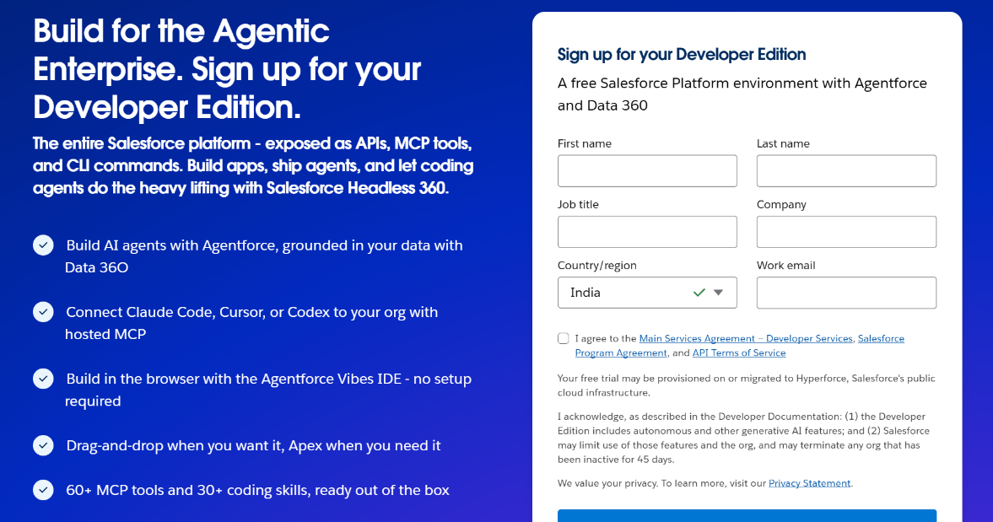
Steps:
- Navigate to the Salesforce Developer signup page.
- Enter the required details in the signup form:
  - First Name & Last Name: Enter your personal details.
  - Email: Provide a valid email address for account verification.
  - Role: Select Developer.
  - Company: Enter your college or organization name.
  - Country: Select India.
  - Postal Code: Enter your location PIN code.
  - Username: Create a unique username using your name and organization.
Example:
yourname@organization.com
- Click on Sign Me Up after completing all required fields.

Activity 2: Account Activation
Steps:
1.Open the inbox of the email address used during Salesforce signup. 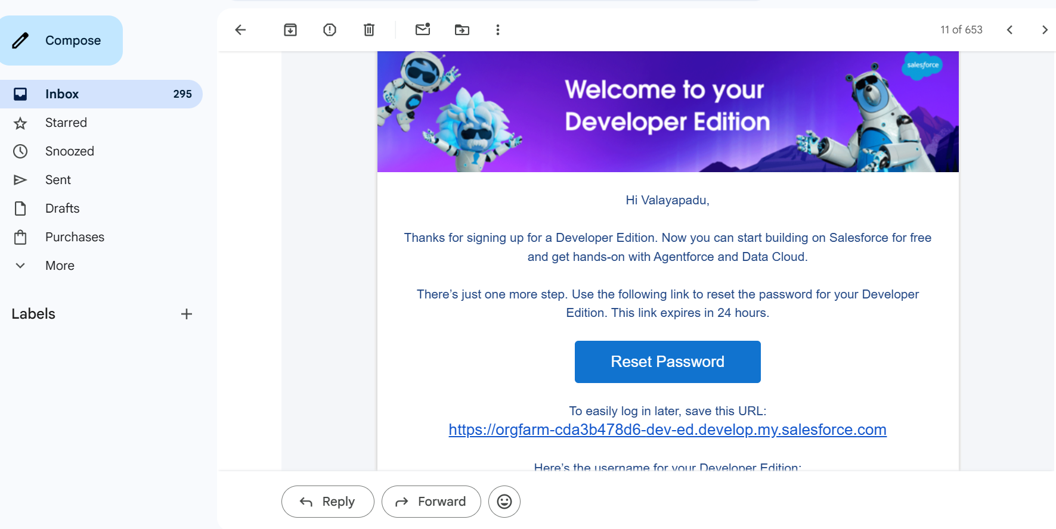Click on the Verify Account link received from Salesforce.
2.Set a new password and complete the security verification process.
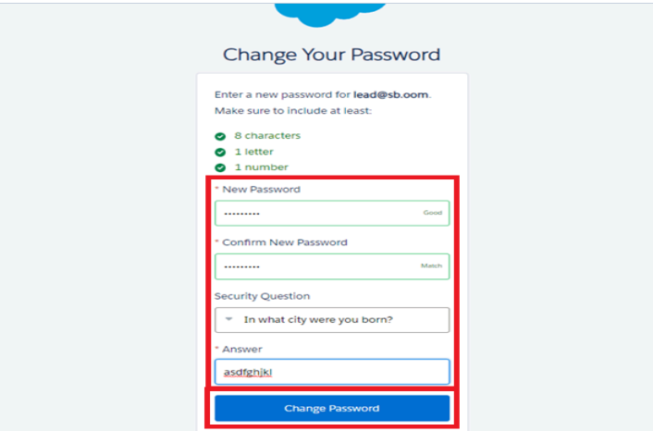
3.After successful verification, you will be redirected to the Salesforce Setup page.
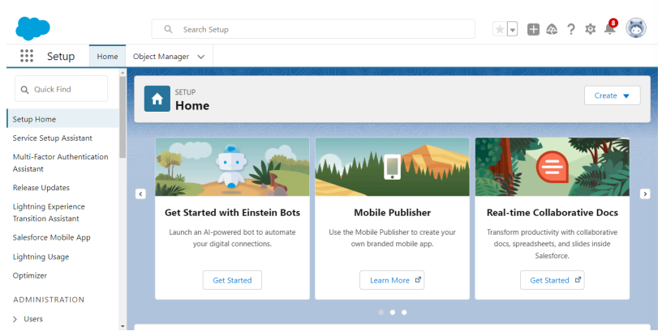
4.The Salesforce Developer environment is now ready for building the AI-Powered Job Recruitment & Candidate Management System.

Milestone 2 – Objects
Objective:
To create custom objects in Salesforce for managing candidate, recruiter, hiring manager, job, and application-related information required for the AI-Powered Job Recruitment & Candidate Management System.
Steps to Create Custom Objects:
- In the Salesforce Organization, click the Gear Icon on the top-right corner and select Setup.
- Navigate to the Object Manager tab.
- If Object Manager is not visible, search Object Manager in the Quick Find box.
- On the Object Manager page, select Create → Custom Object.

Activity 1: Candidate Object
- Go to Setup → Object Manager → Create → Custom Object.
- Enter the following details:
- Label: Candidate
- Plural Label: Candidates
- Record Name Label: Candidate Name
- Data Type: Text
- In Optional Features, select:
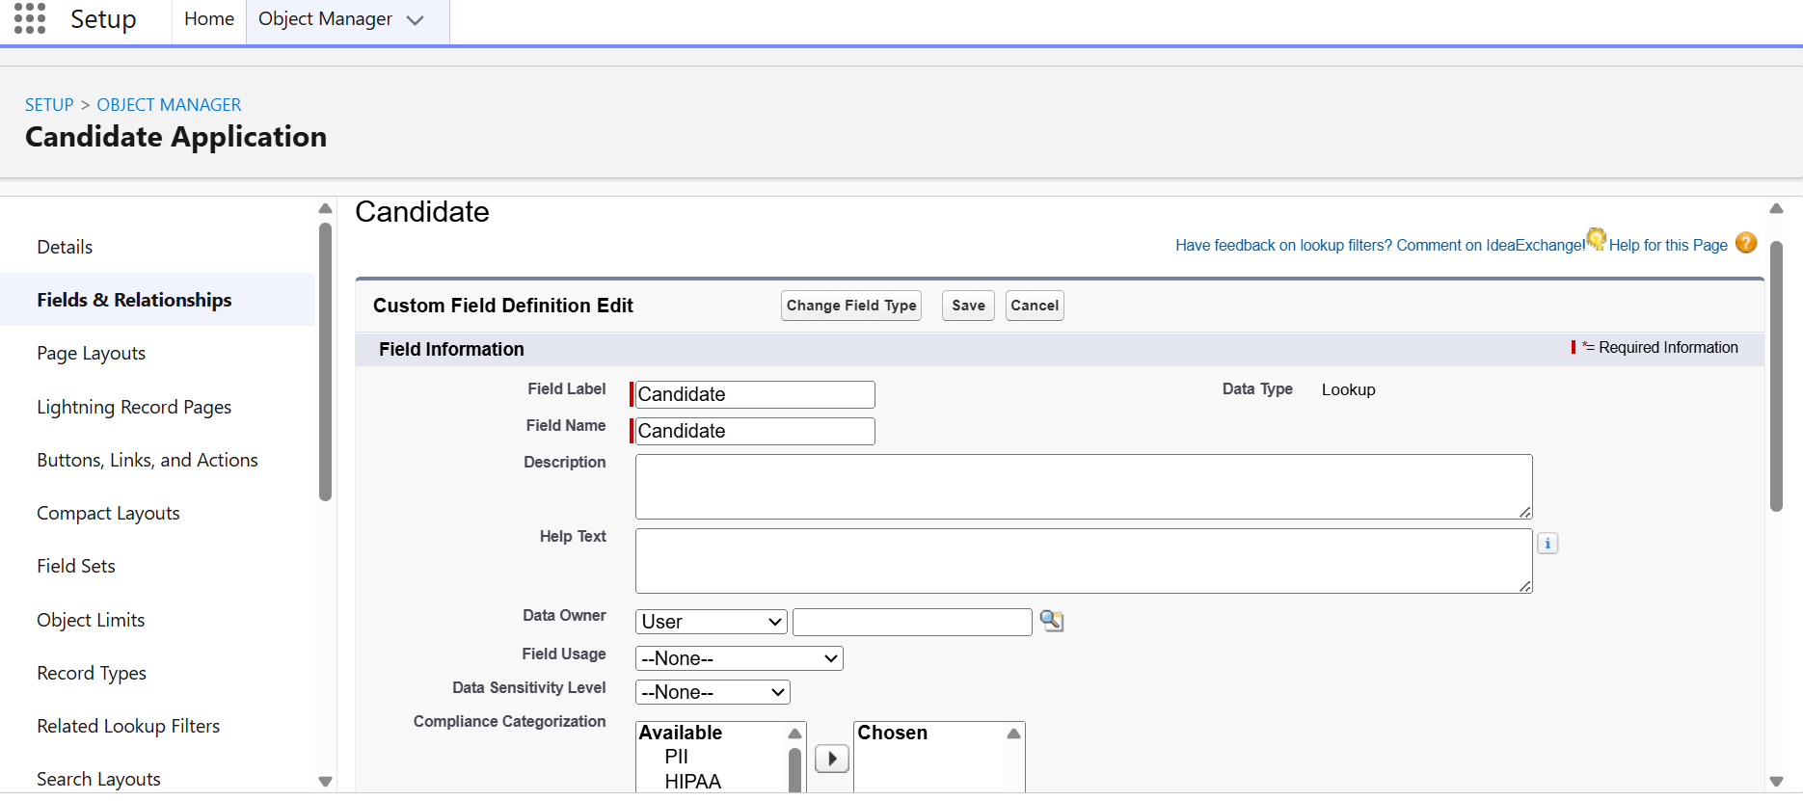
✓ Allow Reports
✓ Allow Activities
✓ Track Field History
- In Search Status, select:
✓ Allow Search
- Click Save.

Purpose:
The Candidate object stores candidate details such as name, contact information, skills, qualifications, resume details, and application status.

Activity 2: Recruiter Object
- Go to Setup → Object Manager → Create → Custom Object.
- Enter the following details:
- Label: Recruiter
- Plural Label: Recruiters
- Record Name Label: Recruiter Name
- Data Type: Text
- In Optional Features, select:
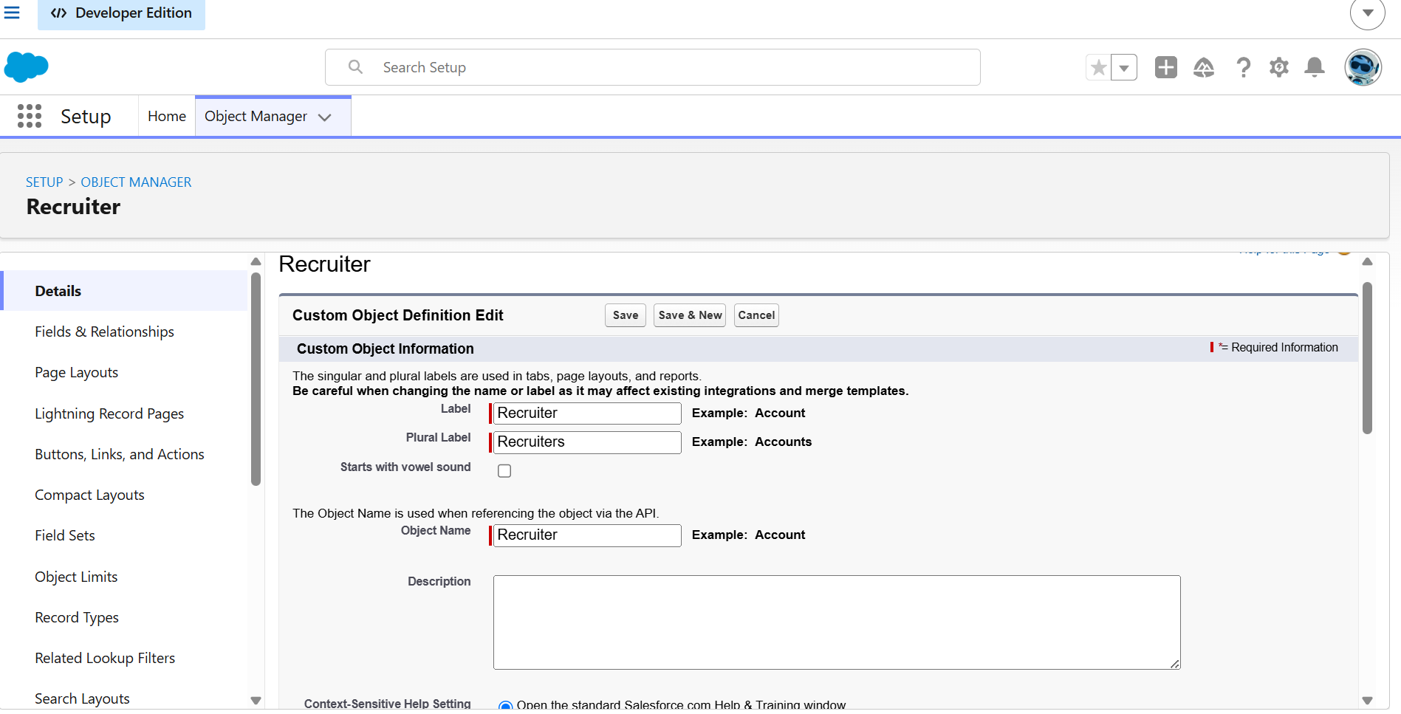
✓ Allow Reports
✓ Allow Activities
✓ Track Field History
- In Search Status, select:
✓ Allow Search
- Click Save.

Purpose:
The Recruiter object stores recruiter information and helps manage recruitment activities.

Activity 3: Job Posting Object
- Go to Setup → Object Manager → Create → Custom Object.
- Enter the following details:
- Label: Job Posting
- Plural Label: Job Postings
- Record Name Label: Job Title
- Data Type: Text
- In Optional Features, select:
✓ Allow Reports
✓ Allow Activities
✓ Track Field History
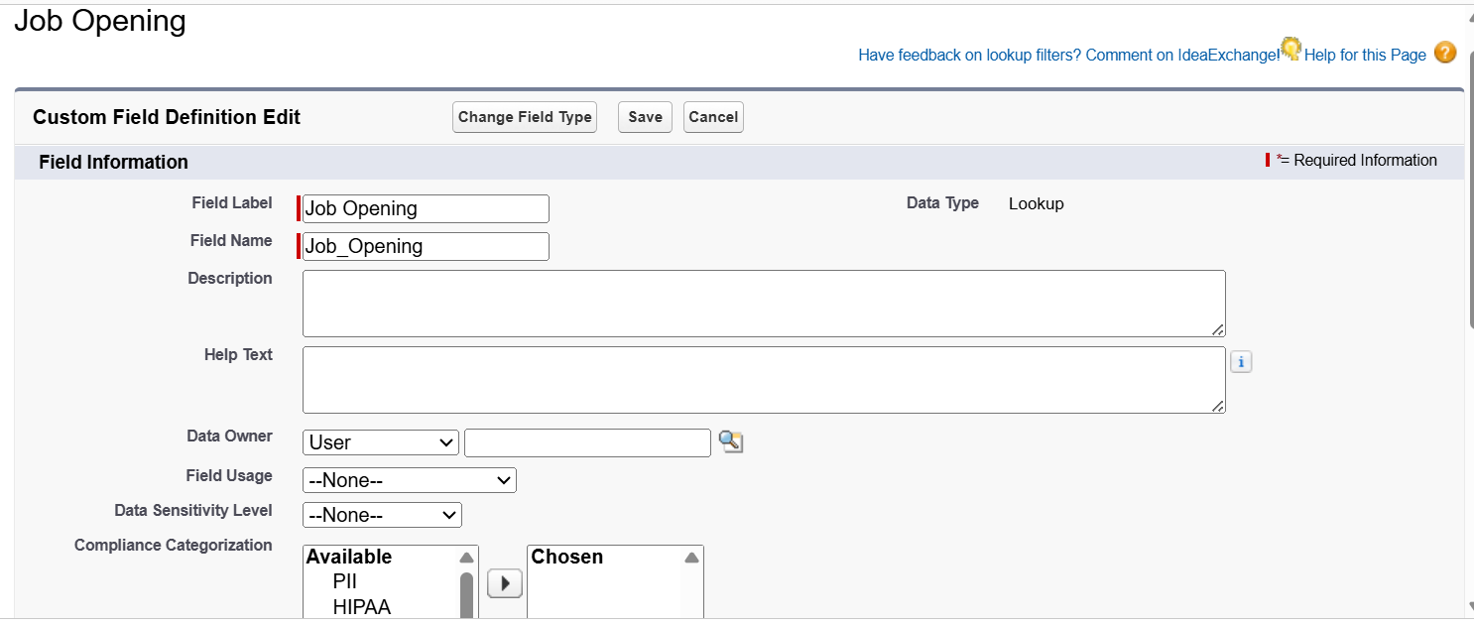
- In Search Status, select:
✓ Allow Search
- Click Save.

Purpose:
The Job Posting object stores job-related information such as job title, description, required skills, experience, and job status.

Activity 4: Application Object
- Go to Setup → Object Manager → Create → Custom Object.
- Enter the following details:
- Label: Job Application
- Plural Label: Job Applications
- Record Name Label: Application ID
- Data Type: Auto Number
- In Optional Features, select:
✓ Allow Reports
✓ Allow Activities
✓ Track Field History
- In Search Status, select:
✓ Allow Search
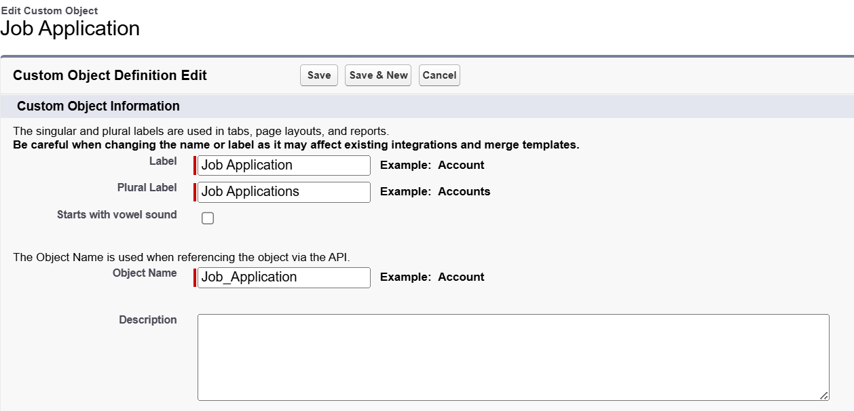
- Click Save.
Purpose:
The Job Application object tracks candidate applications, recruitment stages, interview status, and final hiring decisions.

Objects Created:
Object Name | Purpose
Candidate | Stores candidate profiles and details
Recruiter | Stores recruiter information
Job Posting | Manages available job openings
Job Application | Tracks candidate applications and hiring stages

Milestone 12 – Conclusion
In conclusion, the development of the AI-Powered Job Recruitment & Candidate Management System represents an important step toward improving recruitment efficiency and automation. The system successfully integrates candidate information, recruiter details, hiring manager activities, and job application management into a centralized Salesforce platform.
By using Salesforce automation features such as Flows, Validation Rules, Email Notifications, Reports, and Dashboards, the application reduces manual recruitment efforts, minimizes errors, and improves communication between candidates, recruiters, and hiring managers. The integration of AI-powered capabilities helps in analyzing candidate information and supporting better hiring decisions.
The system enables organizations to manage the complete recruitment lifecycle, from job creation and candidate applications to evaluation and final selection. Real-time reports and dashboards provide valuable recruitment insights, helping organizations make faster and data-driven hiring decisions.

7. FUNCTIONAL & PERFORMANCE TESTING
During the testing phase, screenshots were captured from the Salesforce Lightning interface to verify the correct functioning of the AI-powered recruitment system.
The testing activities include:
- Candidate record creation and management
- Recruiter and hiring manager record verification
- Job posting creation and modification
- Job application tracking through different recruitment stages
- Validation rule testing for candidate details and application information
- Verification of record types and page layouts
- Testing of automated email notifications for application updates
- Testing of Salesforce Flow automation
- Verification of reports and dashboard generation
- Testing of AI-based candidate evaluation features
Performance testing was conducted to ensure fast response time, reliable data processing, and system stability while handling multiple recruitment records and user activities.

8. ADVANTAGES & DISADVANTAGES
Advantages
- Centralized candidate and recruitment data management
- Reduced manual recruitment effort
- Automated application tracking and notifications
- Improved candidate evaluation using AI assistance
- Faster communication between candidates and recruiters
- Real-time recruitment analytics through reports and dashboards
- Improved hiring decision-making
Disadvantages
- Requires Salesforce platform access and licensing
- Internet dependency for cloud access
- Limited offline functionality
- AI recommendations require accurate and complete data
- Initial configuration and customization require technical knowledge

9. Conclusion
The AI-Powered Job Recruitment & Candidate Management System successfully improves the recruitment process by integrating candidate management, job tracking, automation, and analytics into a single Salesforce platform.
The system reduces recruitment delays, improves data accuracy, automates repetitive tasks, and enhances communication through automated notifications. AI-powered features and dashboards provide valuable insights that help recruiters and hiring managers make efficient and informed hiring decisions.

10. FUTURE SCOPE
The future enhancements of the system include:
- AI-based candidate ranking and recommendation system
- Resume parsing and automated skill extraction
- Chatbot integration for candidate queries
- Mobile application support for recruiters
- WhatsApp/SMS notifications for candidates
- Predictive hiring analytics
- Integration with external job portals
- Advanced interview scheduling automation
- Multi-company recruitment support

11. APPENDIX
Source Code: Salesforce Configuration, Custom Objects, Validation Rules, Flows, and Automation Components
Dataset: Candidate Profiles, Job Records, Recruiter Details, and Application Records
Tools Used:
- Salesforce Developer Org
- Salesforce Lightning Experience
- Salesforce Flow Builder
- Salesforce Reports & Dashboards
- Salesforce AI/Agentforce Features

Thank You

